

THE BOARDS OF APPEAL

DECISION
of the First Board of Appeal of 10 November 2025

In case R 697/2025-1

Skechers U.S.A., Inc. II
228 Manhattan Beach Blvd. Manhattan Beach 90266  United States | Applicant / Appellant
represented by D Young & Co LLP, Karlstraße 12, 80333 Munich, Germany APPEAL relating to European Union trade mark application No 19 057 246
THE FIRST BOARD OF APPEAL

composed of G. Humphreys Bacon (Chairperson), E. Fink (Rapporteur) and C. Bartos (Member)

Acting Registrar: K. Zajfert gives the following

Language of proceedings: English

Decision

Summary of the facts
- By an application filed on 19 July 2024, Skechers U.S.A., Inc. II (‘the applicant’) sought to register the position mark

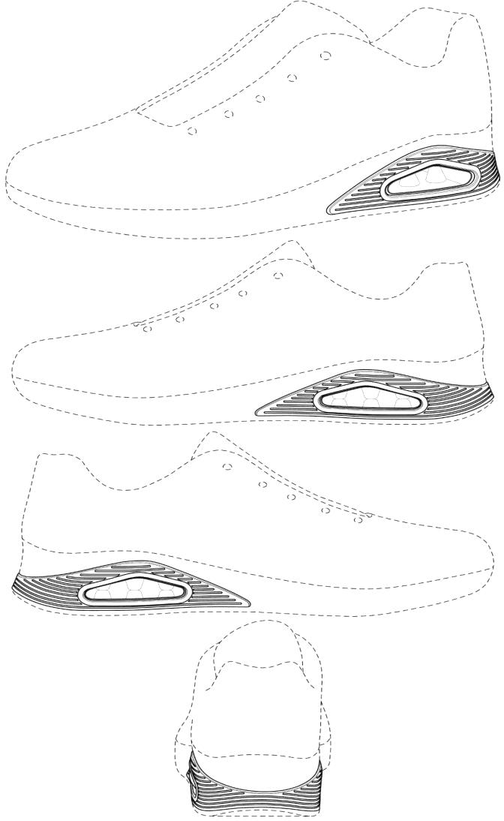

as a European Union trade mark (the ‘EUTM’) for the following goods: Class 25: Footwear.
- The description attached reads as follows:
The mark consists of two graphically depicted concentric triangular-like elements with rounded edges, placed on both sides of footwear, specifically, on the lateral side of each shoe and roughly corresponding to the shoe’s heel, as shown in the attached representation. The outer triangular element bears horizontal grooves of the same colour and the corner closest to the rear of the shoe tapers and stretches horizontally across the

back of the shoe, expanding again to form the rear corner of the triangular element on the opposite side of the shoe. The inner triangle on both sides of the shoe comprises a window within which six frusta-like ‘studs’ can be seen within the sole of the shoe. Three of these ‘studs’ taper downwards from the top of the window and meet the tops of the other three ‘studs’ which taper upwards from the bottom of the window, thereby creating the effect of two rows of teeth within a closed set of jaws, with exaggerated gaps between each tooth. The dotted lines do not form part of the mark and are entered to show the relative size and the position of the mark on the shoe.
- On 22 August 2024, the examiner raised an objection based on lack of distinctive ness under Article 7(1)(b) EUTMR.
- The applicant maintained its request for registration notwithstanding the objection raised by the examiner and added a subsidiary claim of acquired distinctiveness in accordance with Article 7(3) EUTMR and Article 28(2) EUTMIR.
- It submitted various printouts from its website in order to prove the intensive use of the sign applied for (Annex 1) as well as judgments of the General Court, decisions of the Boards of Appeal and excerpts of the EUTM register concerning prior EUTM registrat ions which it considered comparable (Annexes 2-7).
- On 28 March 2025, the examiner took a decision (‘the contested decision’) refusing the mark applied for under Article 7(1)(b) EUTMR for lack of inherent distinctiveness. The decision was based on the following main findings:
  - The goods address the general public who displays an average level of attentiveness. As the sign applied for does not contain any verbal elements, the assessment is to be based on the general public in the entire European Union.
  - The mark applied for cannot be separated from the shape of the goods applied for, namely footwear.
  - Consumers will usually pay more attention to the label or name of the product than to its shape. The sign consists merely of a combination of presentational features, an area in the midsole designed for specific functio ns such as shock absorption or arch support, that would be seen by the relevant consumer as typical of the shapes of the goods applied for. This shape is not markedly different from various basic shapes commonly used in the trade for the goods and is merely a variation of these shapes as demonstrated by the examples included in the objection.
  - The mark does not depart significantly from the norm or customs of the footwear sector. Numerous manufacturers incorporate similar design elements into their products. The combination of rounded triangular shapes, textured horizontal grooves and visible cushioning units within the midsole or heel area is not uncommon in athletic footwear. On the contrary, they are prevalent features that serve both functional and aesthetic purposes, commonly associated with performance and comfort enhancement. The presence of a transparent window with internal elements mimicking a cushioning or support structure is a familiar concept employed by major footwear manufacturers.

  - The mere systematic placement of a design on a specific part of the footwear does not endow it with inherent distinctiveness. The mark must still possess unique characteristics that enable consumers to recognise it as indicating commercial origin. The combination of geometric elements, grooves, and cushioning features remains purely decorative and functional rather than distinctive. The applicant did not demonstrate that the sign departs significantly from customary designs used by numerous brands in the athletic footwear industry.
  - Notwithstanding the importance of the principles of equal treatment and sound administration, the Office must examine every case on its own merits and cannot be bound by previous or erroneous decisions.
  - Once the decision on the lack of inherent distinctiveness has become final, proceedings will be resumed for the examination of the subsidiary claim under Article 7(3) EUTMR.
- On 17 April 2025, the applicant filed an appeal against the contested decision, followed by the statement of grounds on 24 July 2025. It requested that the contested decision be set aside.
- Together with the statement of grounds, the applicant submitted the following documents :
- Annexes 8a-c, 10-14: Printouts from different online stores for footwear, including its own store;
- Annexes 9, 15: Appeal decisions R 2368/2024-2 (23/04/2025, R 2368/2024‑2, DEVICE OF A THREE-LINE SYMBOL WITHIN A SHAPE OF A HOUSE (fig.)) and R 2316/2024-1 (07/04/2025, R 2316/2024‑1, DARSTELLUNG EINES KÜHLERGRILLS (fig.));
- Annex 16: Excerpts from the EUTM register concerning prior registrations of position marks owned by the applicant.

Grounds of appeal
- The arguments raised by the applicant in the statement of grounds may be summarised as follows:
  - The subsidiary claim of acquired distinctiveness is maintained.
  - The applicant agrees with the findings of the examiner that the relevant public consists of the average consumer in the EU who displays an average degree of attentiveness.
  - The mark applied for is inherently distinctive since a minimum degree of distinctiveness is sufficient. Only signs that are excessively simple and composed of a basic geometric shape are unable to convey a message that consumers will be able to remember. The sign applied for is a symmetrical design featuring concentric, rounded triangular shapes with textured grooves that wrap seamlessly around the heel, creating a sense of dynamic movement.

  - Contrary to the examiner’s findings, the sign applied for can be separated from the shape of the footwear itself. Therefore, as held by the Court of Justice in its judgment C-456/19 (08/10/2020, C-456/19, Aktiebolaget Östgötatrafiken, EU:C:2020:813), it is irrelevant whether the sign departs significantly from the norm or customs of the footwear market. The sign applied for does not show the claimed goods but the manner in which it is to be used, namely on the side of a shoe. The concentric triangular shapes with textured grooves are clearly defined graphic elements that are not intended to represent the shape or any functional aspects of the footwear. The specific and consistent placement of the mark on the lateral side near the heel ensures that consumers perceive it as distinguishable from the shape of the footwear and, therefore, as an indication of commercial origin. The elements of the sign are purely aesthetic, without any functional purpose, and are perceived as such by the relevant public.
  - The labelling customs in the footwear sector result in a lower threshold of distinctiveness, as confirmed by case-law. The examples of footwear submitted (Annex 8a) demonstrate that it is customary for footwear manufacturers to display lines, stripes, geometric figures or a combination thereof on the lateral or heel side of the product. The applicant also refers to examples of its own footwear currently available in the EU (Annex 8b) and to footwear of other manufacturers (Annex 8c).
  - Due to the common practice of placing brand-identifying marks on the outer sole of footwear, the relevant public will clearly perceive the position mark applied to the outer sole of the footwear as an object entirely different from the actual product. Consumers will recognise the artistically and symmetrically designed combination of inner and outer triangular elements as a distinguishing feature in relation to footwear of other manufacturers and, therefore, as an indication of commercial origin.
  - Case-law acknowledges that geometric shapes systematically placed on a shoe can operate as distinctive trade indicators.
  - The sign consists of a unique and artistically combination of triangular elements with the following distinctive features: two rounded triangular shapes positioned on each side of the shoe near the heel, two outer triangular shapes with horizontal groves that give them a textured appearance, rear corners of the two outer shapes closest to the heel that taper and form a U-shaped curved connection across the back of the shoe and a window-like opening within the inner triangular shape that contains six frusta- like studs. This combination of distinctive features produces a figurative effect, which is capable of making a memorable impression on the targeted consumer enabling them to distinguish the design from those of other manufacturers. This is in line with the conclusions reached by the Boards of Appeal in its decisions R 1369/2022-5, R 1370/2022-5 and R 1371/2022-5 of 20 December 2022, which allowed the following three position marks of the applicant for registration:
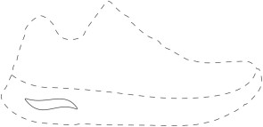
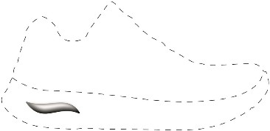
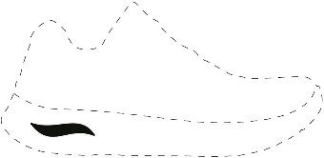


  - The applicant also makes reference to the appeal decision R 2368/2024-2 (Annex 9),

which found the figurative mark to meet the threshold of distinctive ness under Article 7(1)(b) EUTMR.
  - The sign departs significantly from the norm or customs of the footwear sector as demonstrated by the examples of footwear attached that feature air-cushion units in the heel of the shoe that are visible through a window which is typically rectangular or oval in shape (Annexes 10-14). There exists no shoe incorporating a triangular window surrounded by parallel horizontal grooves and a visible internal structure of teeth-like, frustum shaped studs. The triangular window with teeth-like, frustum shaped studs applied for is unique to the application and not common in the industry.
  - Reference is also made to appeal decision R 2316/2024-1 of 7 April 2025 (Annex 15), which accepted the figurative mark 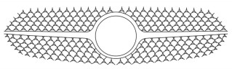for publication on the grounds that the radiator grill of a vehicle has become an element that allows consumers to distinguish various car models of different manufacturers. The principles set out in the decision equally apply to the position mark at hand. In the footwear sector, the logo or emblem on the side of the heel is a key visual element which allows consumers to differentiate between different brands.
  - The prior registrations cited before the examiner confirm the distinctiveness of the mark applied for. In particular, in addition to the prior registrations allowed by the Boards of Appeal, the following prior registrations obtained by the applicant for position marks and identical goods should have been taken into account by the examiner (Annex 16):
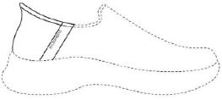
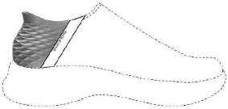
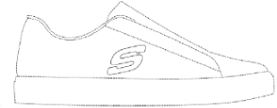
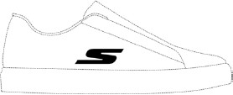
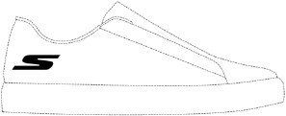
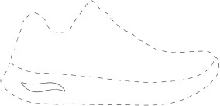
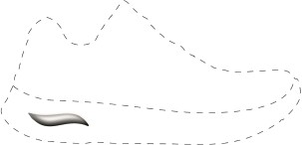
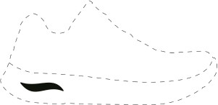
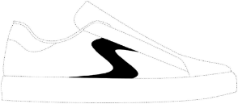
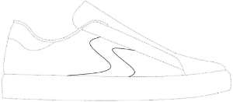

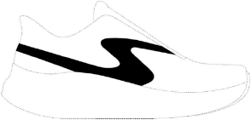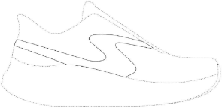
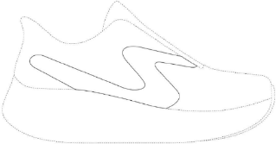
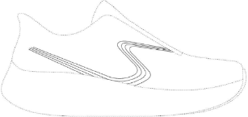

  - The contested decision therefore infringes the principle of equal treatment and the principles of sound administration. The examiner did not justify her decision adequately in the light of the prior registrations referred to by the applicant. Explicit reference is made to the prior registrations submitted as Annex 7 before the examiner.

Reasons
- The appeal is admissible pursuant to Articles 66, 67 and 68(1) EUTMR but not well founded.
- As rightly held by the contested decision, the sign applied for is devoid of inherent distinctiveness pursuant to Article 7(1)(b) EUTMR.

Article 7(1)(b) EUTMR
- Pursuant to Article 7(1)(b) EUTMR, a trade mark may not be registered if it is devoid of any distinctive character. Signs devoid of any distinctive character, as referred to in Article 7(1)(b) EUTMR, are those which are unable to perform the essential function of a trade mark, namely to identify the commercial origin of the goods or services, thus enabling the consumer who purchases them to repeat the experience if it proves to be positive, or to avoid it if it proves to be negative, on the occasion of a subsequent acquisition (09/10/2002, T-360/00, UltraPlus, EU:T:2002:244, § 42).
- The average consumer does not tend to examine a trade mark analytically. Therefore, a trade mark must enable the average consumer of the goods or services in question, who is reasonably well informed and reasonably observant and circumspect, to distinguish the goods or services concerned from those of other undertakings without conducting an analytical or comparative examination and without paying particular attention (12/02/2004, C-218/01, Perwoll, EU:C:2004:88, § 53; 12/01/2006, C-173/04 P,
Standbeutel, EU:C:2006:20, § 29).
- The distinctiveness of a trade mark must be assessed, first, by reference to the goods or services in respect of which registration is sought and, second, on the basis of the perception of that sign by the relevant public (12/09/2019, C-541/18, #darferdas?, EU:C:2019:725, § 20).
- The contested decision correctly considered the goods applied for, i.e. footwear, to be directed at the public at large with an average degree of attentiveness and based the assessment on the relevant public in the entire European Union, a finding not contested by the applicant.

- According to Article 3(3)(d) EUTMIR, a position mark is characterised by the specific way in which the mark is placed or affixed on the goods. Accordingly, the reproduction must not only show the mark, but also its position on the goods and its size in relation to the goods. Position marks in relation to goods, thus, inevitably merge with the appearance of the goods claimed (16/01/2019, T-489/17, DARSTELLUNG EINES FLASCHENVERSCHLUSSES (Posit.), EU:T:2019:9, § 24; 16/01/2014, T‑433/12,
Metallknopf im Stofftierohr, EU:T:2014:8, § 25). Therefore, the mark applied for cannot be separated from the shape of the goods.
- According to the four views of the representation and the accompanying description, the application claims protection for a position mark in the form of two concentric triangular - like elements with rounded edges placed on the lateral sides of a sports shoe that merge at the back of the shoe. The outer triangular-like element bears horizontal grooves, while the inner triangular- like element contains six barely visible frusta-like studs arranged in two rows of three studs each. Both the representation and the description therefore confirm that the sign applied for is indissociable from the appearance of the goods claimed.
- There is nothing to be found in the submissions of the applicant and the evidence provided to support its claim that the two concentric triangular- like elements on each side of the shoe can be separated from the shoe. On the contrary, the screenshots of its website furnished before the examiner to demonstrate the intensive use of the mark (Annex 1) show sports shoes that feature triangular- like elements on the heel which are described as ‘visible air-cushioned Skech-Air midsole’ (sichtbare, luftgepolsterte Skech-Air Zwischensohle). A midsole is an integral part of the shoe and not a separate element applied arbitrarily to the shoe’s heel. The perception of the triangular-like elements as air cushions is moreover confirmed by the evidence submitted on appeal which shows numerous sports shoes of other manufacturers that contain air cushions of geometric shapes in the same area of the midsole (Annexes 10 to 13).
- Contrary to the applicant’s view, the preliminary ruling C-456/19 (08/10/2020, C-456/19, Aktiebolaget Östgötatrafiken, EU:C:2020:813) is not pertinent to the case at hand because the facts are not comparable. The signs at issue in these proceedings claimed protection for transport services in Class 37 intended to be applied to the transport vehicles that enabled the performance of these services. The referring court asked in essence whether, in the examination of the distinctiveness of the sign, the criteria for assessing the distinct ive character of marks consisting of the shape or the surface design of the product would apply.
- To this question, the Court of Justice replied that, although the transport vehicles used for the provision of the services at issue were shown in dotted lines in the applications for registration in order to indicate the outlines of the signs applied for and the places where they were intended to be affixed, these signs were not indissociable from the shape or packaging of those goods and were not intended to represent the physical space in which the services were provided. Therefore, the distinctive character of these signs, which consisted of coloured motifs intended to be affixed exclusively and systematically in a specific manner to a large part of the transport vehicles, should be assessed by taking into account the perception of the relevant public of the affixing of the signs to those goods, without it being necessary to examine whether they departed significantly from the norm or customs of the sector concerned (08/10/2020, C-456/19, Aktiebolaget Östgötatrafiken, EU:C:2020:813, §§ 43,44).

- However, as explained above (s. para. 17), the position mark at hand is intended to be placed on the goods for which protection is claimed and the findings of the prelimina ry ruling C-456/19 cannot apply. To conclude, the sign applied for consists exclusively of elements that are indissociable from the appearance of the footwear claimed.
- Given that position marks in relation to goods are indissociable from the appearance of the product itself, they are similar to the categories of three-dimensional marks and figurat ive marks showing the appearance of the product itself or the design applied to its surface. However, the classification of the application as a position mark is irrelevant for the purposes of the examination criteria under Article 7(1)(b) EUTMR (23/10/2024, T-307/23, DEVICE OF A SPORTS SHOE WITH TWO PARALLEL LINES PLACED ON ONE SIDE (fig.), EU:T:2024:731, § 18; 16/01/2019, T-489/17, DARSTELLUNG EINES FLASCHENVERSCHLUSSES (Posit.), EU:T:2019:9, § 18; 15/06/2010, T-547/08, STRUMPF, EU:T:2010:235, § 21).
- The criteria for assessing the distinctive character of marks consisting of the shape or the surface design of the product itself or a part thereof are no different from those applicable to other categories of trade marks. However, when those criteria are applied, account must be taken of the fact that the perception of the average consumer is not necessarily the same. Average consumers are not in the habit of making assumptions about the origin of goods on the basis of signs that are indissociable from the appearance of the goods claimed. Such signs must, therefore, depart significantly from the norm or customs of the sector in order to fulfil their essential function of indicating origin (05/02/2025, T-195/24, A SHAPE OF A HORIZONTAL STRIPE ON A SILVER FUSELAGE (fig.), EU:T:2025:134, §§ 19, 20; 29/01/2025, T-147/24, POSITION EINES ETIKETTS AN EINER MATRATZE, EU:T:2025:107, §§ 17, 18; 23/10/2024, T-307/23, DEVICE OF A SPORTS SHOE WITH TWO PARALLEL LINES PLACED ON ONE SIDE (fig.), EU:T:2024:731, § 21; 16/01/2019, T-489/17, DARSTELLUNG EINES FLASCHENVERSCHLUSSES (Posit.) ,
EU:T:2019:9, § 19). A simple departure from the norm or customs of the sector is not sufficient, it must rather be a significant one (12/02/2004, C-218/01, Perwoll, EU:C:2004:88, § 49).
- The sign applied for essentially consists of three features, namely (1) two triangular- like elements with rounded edges positioned on each side of the shoe near the heel which merge at the back of the shoe, (2) horizontal groves on the outer triangular- like elements and (3) six frusta-like studs in the inner triangular-like elements arranged in two rows of three studs each.
- The two triangular- like elements with rounded edges represent a minor variation of a triangle, which is a basic geometric figure that is not, in itself, capable of conveying a message which consumers will be able to remember, with the result that they will not regard these elements as a trade mark unless they have acquired distinctive character through use (13/11/2024, T-426/23, DEVICE OF BLUE AND YELLOW OVAL SHAPE
(fig.), EU:T:2024:807, §§ 28-30). The perception of these two elements as basic geometric figures is not affected by the fact that the outer triangular shapes merge at the back of the shoe. Given that the elements are applied to the heel area, consumers will understand that the connection at the back simply follows the shape of the heel.
- Likewise, the horizontal grooves are nothing but thin stripes. Irrespective of whether they could be regarded as basic geometric figures, they are nothing more than a simple generic embellishment if placed on a shoe (23/10/2024, T‑307/23, DEVICE OF A SPORTS SHOE

WITH TWO PARALLEL LINES PLACED ON ONE SIDE (fig.), EU:T:2024:731, § 40; 04/12/2015, T‑3/15, DEVICE OF FIVE STRIPES (fig.), EU:T:2015:937, § 18). With
regard to the studs, it is to be noted that they are barely visible and placed in the air cushioning unit. Given that consumers do not tend to examine a sign analytically (s. para. 13), they will simply perceive these studs as serving a technical function, namely air cushioning designed to minimise articular or skeletal impact damage during athletic performance, and not as an indication of commercial origin.
- The combination of these non-distinctive elements does not add anything that would allow consumers to identify the sign as coming from a particular undertaking. It remains nothing but a simple geometric configuration combined with functional elements in the form of the studs that consumers will not perceive as an indication of commercial origin. The overall impression of the sign as a whole is no more than the sum of the elements of which it is composed.
- As correctly held by the examiner, neither the connected triangular- like elements, the horizontal groves and the studs nor their combination depart significantly from the norm or customs of the relevant footwear sector. The examples of footwear provided by the examiner and the evidence furnished by the applicant (in particular Annexes 10-13) demonstrate that it is common in the footwear sector to combine a visible air cushioni ng unit in the heel area of a shoe containing studs with other decorative features on the outer edge of the midsole. The numerous examples of sport shoes also prove that it is not uncommon to combine basic geometric shapes with grooves and to surround the visib le air cushioning unit by a second geometric shape.
- Air cushioning units in the form of simple geometric shapes are for instance present in the following shoe models: in the model ‘Nike Air Max Dn’ (Annex 10) in the form of circles, in the model ‘Nike Air Max Plus’ (Annex 10) in an oval form and in the model ‘UA Summit Trek shoes for men’ in a rectangular form (Annex 13). The visible air cushioni ng unit contains studs in the following shoe models: ‘Chaussures de Skate Air 4’, ‘Nike Homme Air Excee Sneakers’ (included in the contested decision) and ‘Nike Air Max 90’ (Annex 10). The air cushioning unit is surrounded by another geometric shape in the following shoe models: ‘Nike Homme Air Max Excee Sneakers’, ‘Hitmars Chaussure de Course’ (included in the contested decision) and ‘Nike Air Max Command woman shoe’ (Annex 10), in the latter case the surrounding element resembles a triangular with rounded edges. Grooves within the geometric shape surrounding the air cushioning unit are present in the following shoe models: in the models ‘Nike Air Max 90’ (Annex 10) and ‘Hitmars Chaussure de Course’ (included in the contested decision) in the form of horizonta l grooves, in the model ‘X-Cell Lightspeed Running Shoes’ (Annex 11) in the form of vertical grooves and in the model ‘Nike Homme Air Max Excee Sneakers’ (in the contested decision) in the form of diagonal grooves.
- Contrary to the applicant’s claim, it is irrelevant that the examples cited above do not show the exact same combination of the features that make up the contested sign. The examination of distinctiveness is not an examination of novelty. It is therefore not necessary to prove the identical anticipation of the sign applied for in the existing range of shapes and designs (29/06/2015, T-618/14, SNACKS CON FORMA DE TACO (3D), EU:T:2015:440, § 41; 11/06/2009, T-78/08, PINZETTE (3D), EU:T:2009:199, § 39; 31/05/2006, T-15/05, SHAPE OF SAUSAGES (fig.), EU:T:2006:142, § 40). The sign
applied for constitutes a mere variation of functional or decorative elements placed on the

midsole of sports shoes and therefore will not be perceived by the relevant public as an indication of commercial origin.
- The applicant’s argument that case-law has established a lower threshold of distinctive ness for the footwear sector is to be rejected. Apart from the applicant’s rather global reference to the use of trade marks ‘on the lateral or heel sides’ of sports shoes, it did not identify a single example which would show that use on the heel. On the contrary, to the extent that the examples show elements placed on the heel area of the shoes, these consist exclusive ly of a combination of functional and decorative devices, namely air cushioning units of different shapes.
- In addition, the General Court has held on several occasions that the mere fact that shoe manufacturers have developed a practice of affixing their mark to the side of shoes does not make it possible to determine that the average consumer has learned to establish an automatic link between the sign featuring on the side of a shoe and a particula r manufacturer and that that consumer will therefore necessarily perceive any geometric shape or combination thereof placed on the side of a shoe as being a trade mark (23/10/2024, T‑307/23, DEVICE OF A SPORTS SHOE WITH TWO PARALLEL LINES PLACED ON ONE SIDE (fig.), EU:T:2024:731, § 43; 04/12/2015, T‑3/15, DEVICE OF FIVE STRIPES (fig.), EU:T:2015:937, § 26).
- There is no case-law to support the applicant’s claim that simple geometric shapes placed on the side of a shoe necessarily have distinctive character. On the contrary, the General Court has expressly clarified that even if some simple geometric shapes placed on the side of a shoe make it possible for the average consumer to establish a link between the product on which they are placed and a specific manufacturer, the distinctive value of those signs is explained less by their positioning on the product than by the intensive use which has in fact been made of them on the market (23/10/2024, T‑307/23, DEVICE OF A SPORTS SHOE WITH TWO PARALLEL LINES PLACED ON ONE SIDE (fig.), EU:T:2024:731,
§ 45; 04/12/2015, T‑3/15, DEVICE OF FIVE STRIPES (fig.), EU:T:2015:937, § 27).
- For the same reasons, the applicant’s reference to the decision R 2316/2024-1 is to no avail. It is based on the explicit findings of the Court in previous judgments that radiator grills and headlights have become an essential element in the appearance of cars that allow consumers to distinguish different car models of different manufacturers (R 2316/2024-1,
§§ 17, 18). However, as confirmed by the case-law cited in paragraph 33, this does not hold true for simple geometric shapes placed on the side or, as in the case at hand, the midsole of a sports shoe.
- In summary, neither the sign itself nor its specific position on the goods claimed deviates significantly from the norm or customs of the footwear industry. The sign applied for is therefore devoid of inherent distinctiveness in the entire European Union within the meaning of Article 7(1)(b) EUTMR.

Prior registrations
- As correctly stated by the examiner, the applicant’s reference to prior registrations does not justify any other conclusion. The relevant legal standard is not that of a previous registration practice (27/02/2002, T-106/00, Streamserve, EU:T:2002:43, § 66; 12/02/2009, C-39/08, Volks.handy, EU:C:2009:91, § 13), but the principle of equal treatment, which, however, applies only within the boundaries of the principle of legalit y

(Streamserve, § 67). The examination of absolute grounds for refusal must be full and stringent (10/03/2011, C-51/10 P, 1000, EU:C:2011:139, § 77; 06/05/2003, C-104/01,
Libertel, EU:C:2003:244, § 59). As the Office has no discretion to refuse or allow a trade mark application, the principle of legality of administration requires that, in all instances, the necessary decision be made if the legal requirements in respect thereof have been met, irrespective of whether different decisions should have been made in previous cases (27/02/2002, T-106/00, Streamserve, EU:T:2002:43, § 67). For the reasons set out above, the refusal of the sign applied for is in line with standing case law (23/10/2024, T‑307/23, DEVICE OF A SPORTS SHOE WITH TWO PARALLEL LINES PLACED ON ONE SIDE (fig.), EU:T:2024:731, § 45; 04/12/2015, T‑3/15, DEVICE OF FIVE STRIPES (fig.), EU:T:2015:937, § 27).
- For the sake of completeness, the Board adds that none of the prior registrations obtained by the applicant and relied upon in the statement of grounds (s. para. 9) are comparable to the sign applied for. They either refer to signs placed on the side of a shoe and not in the heel area or to signs that cannot be considered to constitute basic geometric shapes.
- To sum up, the appeal has to be dismissed.

Article 7(3) EUTMR
- The Office will deal with the applicant’s subsidiary claim of acquired distinctiveness once this decision to reject the application under Article 7(1)(b) EUTMR has become final.

Order

On those grounds,

THE BOARD

hereby:
Dismisses the appeal.

Signed  G. Humphreys Bacon | Signed  E. Fink | Signed  C. Bartos

Acting Registrar:  Signed  p.o. P. Nafz | 

